Page | **1**

1.

a) **Answer:** The Microsoft Illustrations group allows us to insert pictures, shapes, smart art, and charts into our required document. These options will enhance the layout and appearance of our documents. Drawing Tools and Picture Tools tabs only appear when a graphic image is selected.

Pictures:

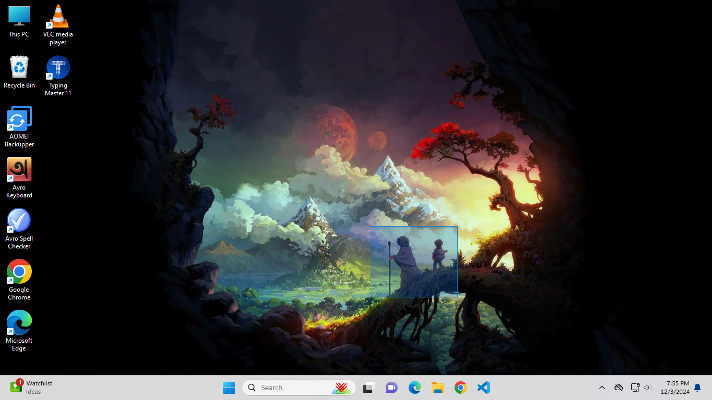

Online pictures:

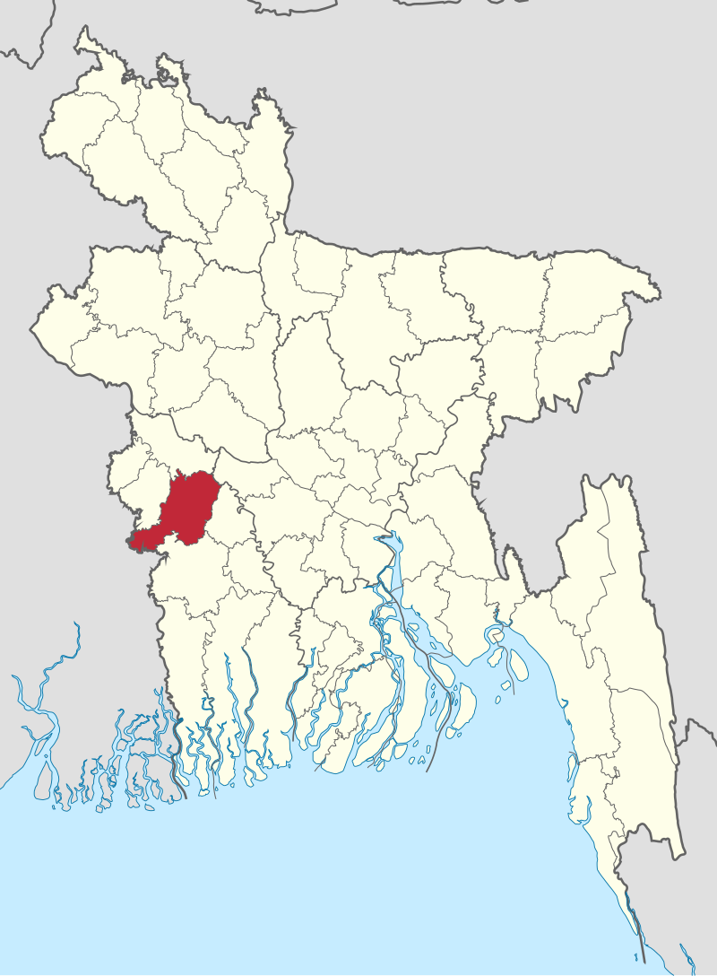

Shapes:

Smart Art:

Pi Chart:

Screenshort:

Bijoy Ekushe

b)

**Jhenaidah District** is a district in southwestern Bangladesh. Part of the khulna division , the district has an area of 1,964.77 km2 . It is bordere to the north,  to the sou to the eas and West Bengal to the west. The largest city and headquarters of this district At the beginning of the British rule, Jhenaidah was a police outpost and was turned into in 1793. The Jhenaidah sub-division was established in 1862. It became a district in 1984.

c)

d)

|  |  |  |  |  |
| --- | --- | --- | --- | --- |
| January Tests | | | | |
| Surname | Name | English | Germen | Computer |
| XUEREB | Norbert | 85 | 42 | 98 |
| Spiteri | Richard | 53 | 45 | 75 |
| Briffa | Paola | 42 | 25 | 48 |
| Brog | Clive | 55 | 85 | 82 |
| caruana | Michelle | 45 | 45 | 25 |

When your table needs more data, add rows and columns, or remove them to get rid of empty cells.

**Add a row**

1. Select a cell.
2. Select the **Table Tools Layout** tab > **Insert Above** or **Insert Below**.

**Add a column**

1. Select a cell to the right or left of where you want the new column to appear.
2. Select the **Table Tools Layout** tab > **Insert Left** or **Insert Right**.

**Delete a row or column**

1. Select a row or column that you want to delete.
2. Press Backspace, or select the **Table Tools Layout** tab >**Delete**, and then select an option.

**Note:** In Excel, select a row or column that you want to delete, right-click and select **Delete** , and choose the option you want. Or select a cell, and then select **Home** > **Insert** or **Home** > **Delete**, and then choose an option.